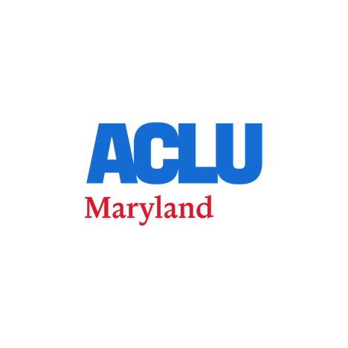

MEDIA ADVISORY

Court Schedules First Hearing in DOJ Lawsuit Demanding Maryland Voter Data

https://www.aclu-md.org/press-releases/court-schedules-first-hearing-in-doj-lawsuit-demanding-maryland-voter-data/

Advisory for: 10:00am Wednesday, June 10, 2026

Contact:
ACLU MD, media@aclu-md.org
Common Cause, mmajikas@commoncause.org

BALTIMORE, MD — On Wednesday, June 10, at 10 a.m., a federal court will hold the first hearing in United States of America v. Demarinis, a case centered on the U.S. Department of Justice’s (DOJ)’s demand for the personal data of all registered Maryland voters.

A coalition of civil rights organizations—including Common Cause Maryland, Out for Justice, the ACLU National Voting Rights Project, and the ACLU of Maryland—alongside individual Maryland voters, filed a motion to intervene in the case to protect voter privacy and prevent potential disenfranchisement.

WHAT: A federal court hearing in United States v. Demarinis, in which civil rights organizations and Maryland voters have intervened to block the Department of Justice from seizing sensitive personal data on every registered voter in the state

WHEN: Wednesday, June 10 at 10 a.m. ET

WHO: Joanne Antoine, Executive Director of Common Cause Maryland; Trina Selden, Founder and Executive Director of Out For Justice; Jonathan Topaz, Staff Attorney, ACLU Voting Rights Project

WHERE: 101 W. Lombard Street, Courtroom 1A, Baltimore, MD 21201. Attorneys and organizational leadership will be available for brief press interviews immediately outside the courthouse following the conclusion of the hearing.

Background for Reporters:

In July 2025, the Department of Justice demanded that the State of Maryland turn over the full names, addresses, dates of birth, driver’s license numbers, and partial Social Security numbers of every registered voter in the state — highly sensitive data protected under Maryland and federal law.
In December 2025, Common Cause, Out for Justice, and three Maryland voters joined the ACLU of Maryland and the ACLU National Voting Rights Project in filing a motion to intervene to block the demand. The intervenors argue the data grab threatens voter privacy, could enable mass voter purges, and would chill participation among naturalized citizens, returning citizens, and other vulnerable communities.
The DOJ's unprecedented demand for Maryland's private voter data has sparked widespread alarm among civil rights groups who argue the data could be shared with bad-faith actors to prevent eligible voters from casting their ballots. Similar legal battles and interventions are currently being fought by civil rights advocates in states across the country.

###

